Go to Amazon SNS and create a topic with random name   
got my ARN arn:aws:sns:us-east-2:756212760270:dem

Create a Subscription and add my Email there for test.  
[frazzhd123@gamil.com](mailto:frazzhd123@gamil.com)

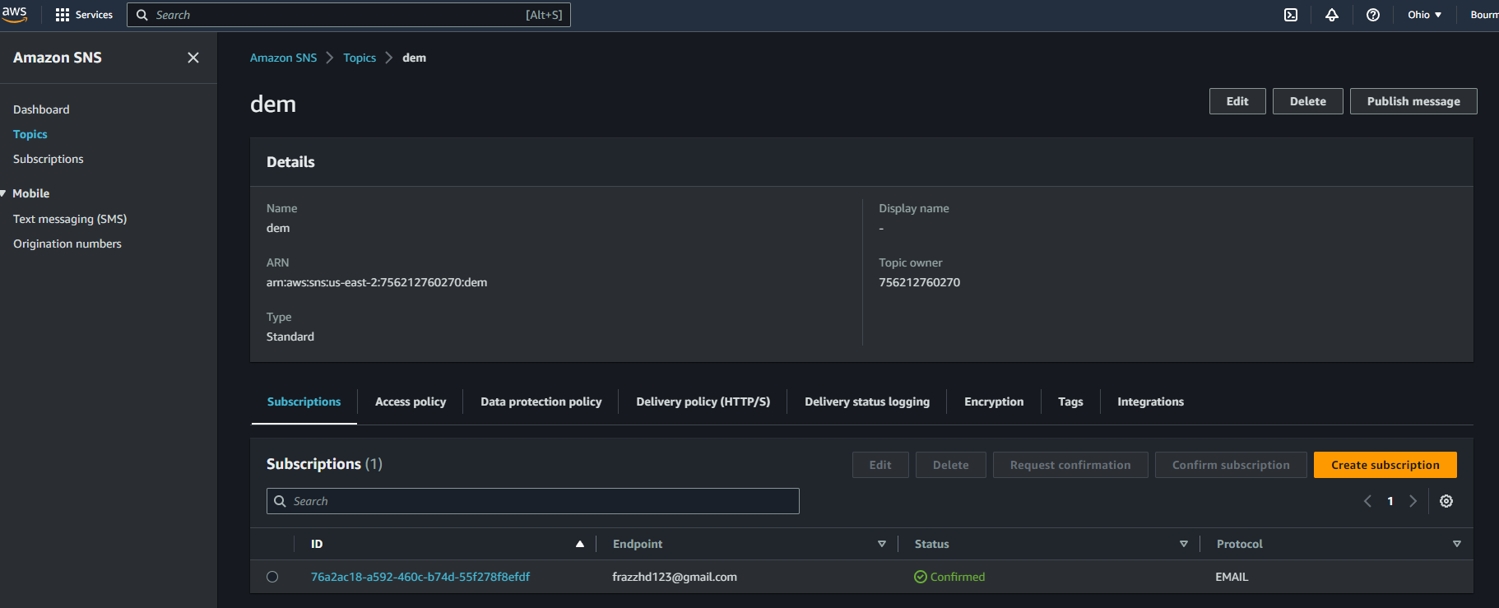

Go to Lambda Create a new function using Python

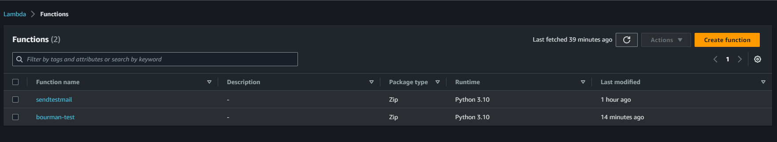

click on Add destination add the Amazon SNS   
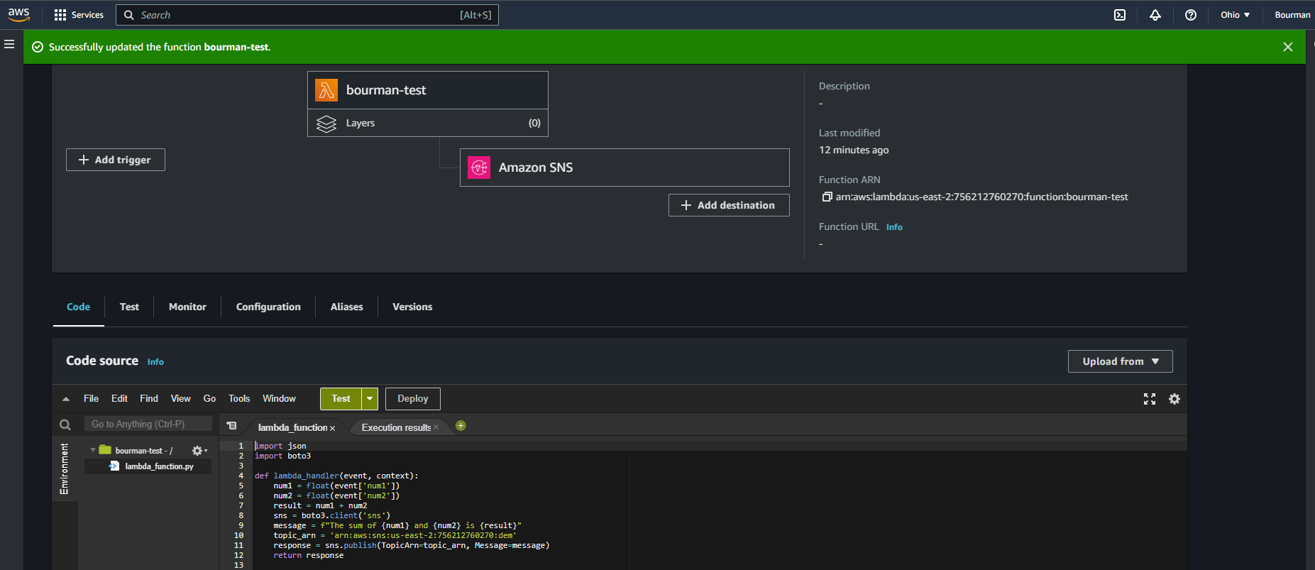

**then put my code function:**   
import json  
import boto3  
def lambda_handler(event, context):

num1 = float(event['num1'])

num2 = float(event['num2'])

result = num1 + num2

sns = boto3.client('sns')

message = f"The sum of {num1} and {num2} is {result}"

topic_arn = 'arn:aws:sns:us-east-2:756212760270:dem'

response = sns.publish(TopicArn=topic_arn, Message=message)

return response

Deploy and on the TEST put   
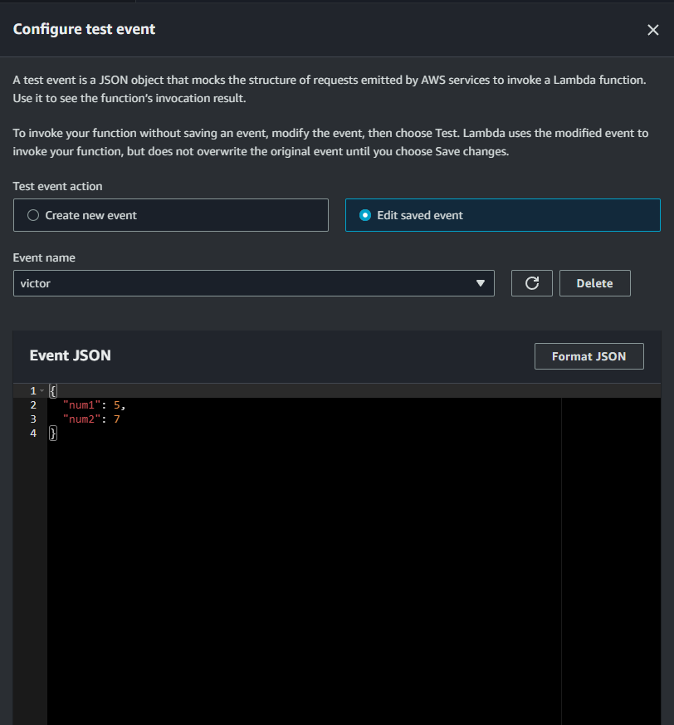

Then run the lambda and go to Email check the result.  
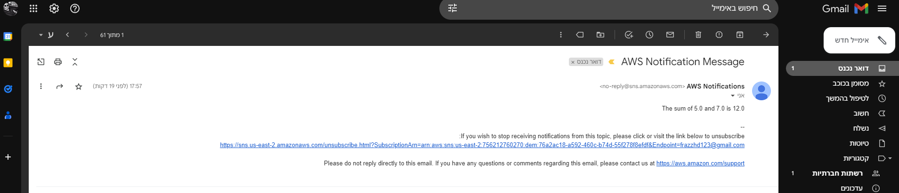

**“The sum of 5.0 and 7.0 is 12.0”**

Steage 2 :   
create a AWS API Gateway

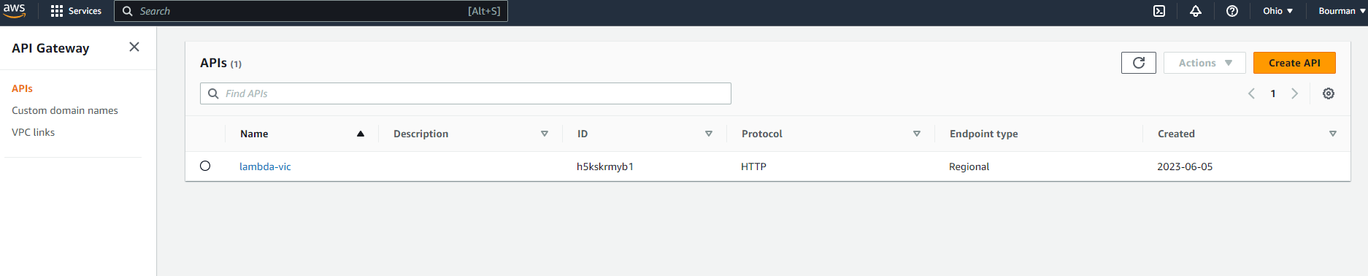

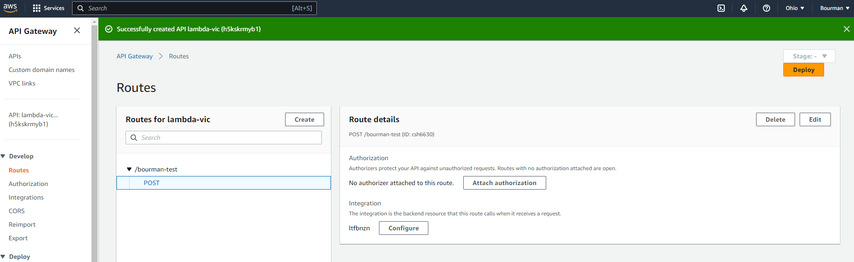

I got the url <https://h5kskrmyb1.execute-api.us-east-2.amazonaws.com/bourman-test>

Go to postman and run

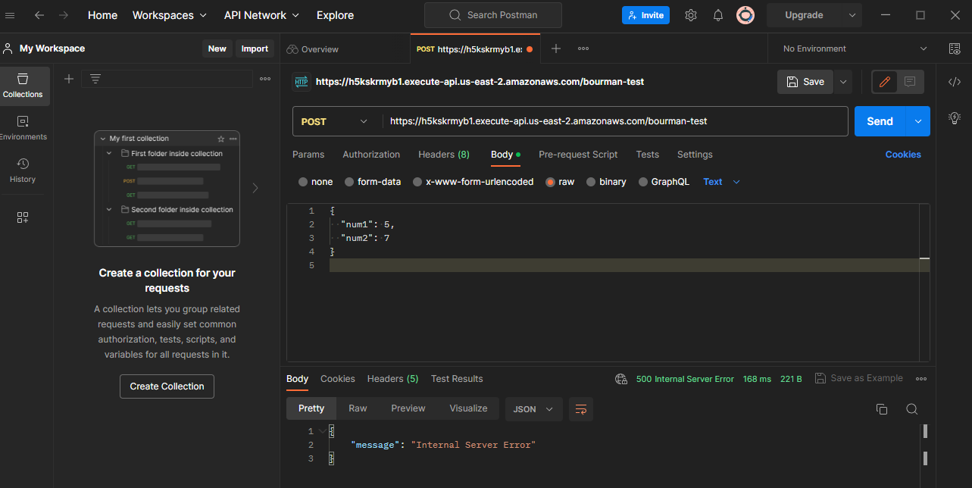  
I got any error and go to aws cloud watch to check the logs   
